Process
Here is a process flow out of blog pipeline
graph TD
A[Create Branch] -->|Push| B(Create PR)
B --> C{Trigger Build}
C -->|Passes | E{Release branch}
E -->|Pr/feature | F[s3 demo bucket]
E -->|master | G[s3 prod bucket]

Rendered in Azure DevOps
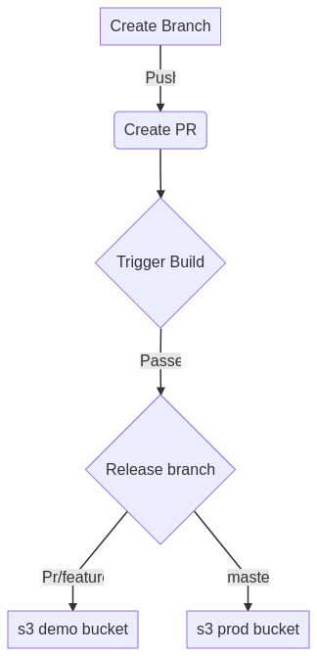
Figure 1: process.png

